**Infected Malaria Cell Image Classification using Deep Learning**

Malaria is a life-threatening disease caused by parasites that are transmitted to people through the bites of infected female Anopheles mosquitoes. It is preventable and curable. Malaria causes symptoms that typically include fever, tiredness, vomiting, and headaches. In severe cases, it can cause yellow skin, seizures, coma, or death.

Our task is to Deep Learning algorithm that is able to classify whether the detected cell is infected or uninfected by the parasite.

A total of 27,558 images were gathered for the development of a deep learning model that can accurately predict the cell that is infected with malaria and the one that is not infected with malaria. The total number of images used to train the model is 22,048 and a total of 5,510 images to validate the model.

One of the important things in the data preprocessing was to resize the malaria cell images as the images were of various sizes. The images were resized to 128 by 128.

In this project, I applied a Deep Learning algorithm, specifically a Convolutional Neural Network (CNN) algorithm that is able to classify whether the image from a certain cell is infected or not simply by training the algorithm to the given images as training. Since this is a heavy load project with data of more than 330 MB, I used this in Jupyter Notebook.

Images for malaria-infected cells:

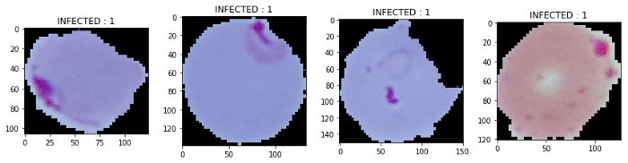

Images for malaria uninfected cells:

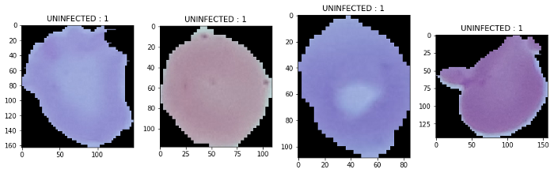

From the images of the cells infected with malaria and uninfected cell images, it can be seen that one can observe the small clot inside the cellular images for the infected cells and that uninfected cells are clean without any clot in the cellular image.

The Keras deep learning framework was used for building the convolutional neural network. Necessary libraries were imported from Keras to train the model.

The defined sequential model takes (None, 150, 150, 3) input. Stack 3 convolutional layers with kernel size (3, 3) with a number of filters (32, 32, 32). Add 2×2 pooling layer after every 2 convolutional layers. Added a dense layer with 512 neurons and a second dense layer with two neurons for classes. The activation function used were Relu and Sigmoid.

The model was compiled using the Adam optimizer loss = 'binary_crossentropy' and the model was trained and validated over twenty-five (25) epochs with accuracy as metric for model evaluation.

The model had an accuracy of 1.00 on the train set and an accuracy of 1.00 on the validation set. This shows that the model predicts and can predict if a cell is infected or uninfected with malaria.

The confusion matrix and the Classification report demonstrate that the model accurately predicts and can accurately predict if a cell is infected or not infected with malaria.

## **GUI for Malaria Cell Image Classification**

The system that was made previously only came to conducting training and testing on the Convolutional Neural Network architectural model that was created. The accuracy of the training and testing produced is also good. This can be seen from the Confusion Matrix displayed at the end of the test. But the system created still has shortcomings. Yes, Graphical User Interface. The system that has been made is quite suitable where this system has successfully carried out the test with an accuracy of 100%. However, this system can only be run by a Machine Learning Engineer who implements the calculations to perform classification/prediction into a program. Remember, the goal is to help health workers make it easier to diagnose. This means that this system must be run or operated by the user (in this case, the user in question is a health worker) to detect or classify which cell images are infected with malaria and which are not infected. For this reason, we need to create a GUI so that it is easier for health workers or users to operate the system created. Streamlit’s open-source app framework is a breeze to get started with. Streamlit is the main library needed to create web apps.

The simple explanation, if the user presses the predict button, then he also act an action on the Generate pred variable and will perform actions such as, the system will open the image file to be uploaded, then it will call the import function and the prediction is made and perform the prediction then it will show the label ‘Parasitized’ ‘ or ‘Uninfected’ of the image.